Assignment-4
Q. Create a Jenkins job to deploy index.html from GitHub repository on amazon s3-static website hosting using CLI commands.
Answer.
Steps:
- Launch EC2 instance and connect with terminal
- Install Git and create index.html (static website file) & push into GitHub remote repository
- Setup Jenkins Dashboard (download: JAVA17tomcat 10Jenkins latest WAR file)
- Give access of AWS account to Jenkins manually
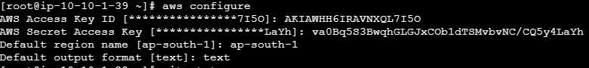
- Create a Jenkins job which will copy index.html from GitHub repository and deploy it on Amazon S3 bucket to host a static website
Explore step 5:
- Create free style job:
- Configure github repository- my-repo (Which contain static website files)

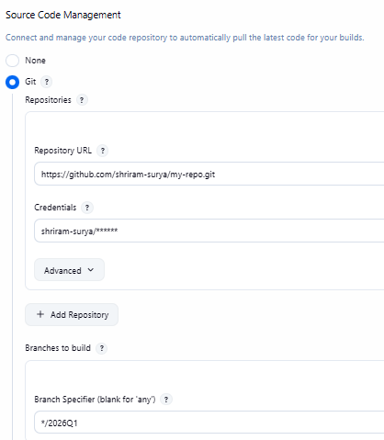

- Configure build step:
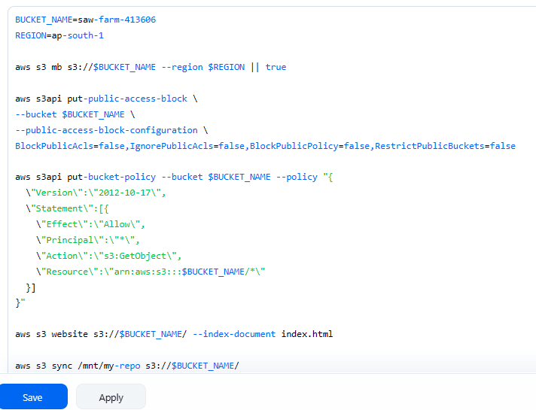

Explanation of script:
- Define variables: bucket name- static website will host here and region-location
BUCKET_NAME=saw-farm-413606
REGION=ap-south-1
- Create bucket ( if not created) and “||true” this syntax will continue further script even if bucket creation command fails because of when bucket has already created
aws s3 mb s3://$BUCKET_NAME --region $REGION || true
- Disable block public access: Public access of S3 bucket is blocked by default so when we try to open that website-it will show access denied
aws s3api put-public-access-block \
--bucket $BUCKET_NAME \
--public-access-block-configuration \
BlockPublicAcls=false,IgnorePublicAcls=false,BlockPublicPolicy=false,RestrictPublicBuckets=false
- BlockPublicAcls=false ----Do not block public access
- BlockPublicAcls=false ---Do not ignore ACL
- BlockPublicPolicy=false ----Allow public bucket policy
- RestrictPublicBuckets=false ----Do not restrict public bucket

- Apply bucket policy (PUBLIC ACCESS): This policy will set s3 bucket rules
aws s3api put-bucket-policy --bucket $BUCKET_NAME --policy "{
\"Version\":\"2012-10-17\",
\"Statement\":[{
\"Effect\":\"Allow\",
\"Principal\":\"*\",
\"Action\":\"s3:GetObject\",
\"Resource\":\"arn:aws:s3:::$BUCKET_NAME/*\"
}]
}"
- aws s3api ------aws s3 low level command for adv operations
- put-bucket-policy ----set rules on this bucket
- --bucket $BUCKET_NAME ----Define bucket name
- --policy -----define policy
- “Version” ----Policy format version(AWS standard)
- “Statement” ----You can set multiple rules
- "Effect": "Allow" ----It says yes to permission
- "Principal": "*" ----Define whom to give permission (* means All Public IP)
- "Action": "s3:GetObject" ----Define which action allowed
- "Resource": "arn:aws:s3:::$BUCKET_NAME/*" ----Define files for which access is given
- Enable static website hosting:
aws s3 website s3://$BUCKET_NAME/ --index-document index.html
- aws s3 website -----Tells S3 to enable static website
- s3://$BUCKET_NAME/ -----Define bucket name
- --index-document index.html ----Define main page of website
- Upload files: This will sync your S3 bucket & your project folder in git repository
aws s3 sync /mnt/my-repo s3://$BUCKET_NAME/

- click on Save and then Apply
- Now your Jenkins job created so you can access static website using s3-bucket URL/Object URL
